Brandon Lee  
14010627X  
12/2/14  
Lab 11

*Complete project is included. Full working source code can be found there.*

**Problem 1**

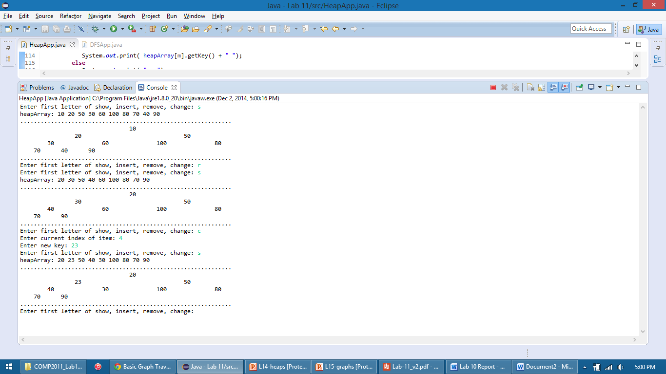

**Problem 2**

